VendorPulse by Zensar
Agentic AI for Governance Cycle Automation · 1-week prototype sprint

Team
Architect (solution design, integration oversight)
Project Manager (project and delivery management)
Dev 1 - Meeting & scheduling agent
Dev 2 - Scorecard collection & validation agent
Dev 3 - Meeting support & minutes agent
Dev 4 - Cross-cycle memory & analytics
Dev 5 - Dashboard UI & demo shell

VendorPulse - Product Requirements
Prototype v1.0 | Zensar Technologies Prepared for: Shell EGB/QBR Governance Automation Demo Sprint duration: 5 working days Status: Draft - for internal team alignment

1. Document Purpose
This PRD defines the scope, features, user stories, acceptance criteria, and technical requirements for VendorPulse v1.0 - a working prototype of an Agentic AI platform that automates the administrative and analytical workflow surrounding Shell's EGB (Executive Governance Board) and QBR (Quarterly Business Review) cycles.
The prototype will be presented to Shell as a live, demoable product deployed for a reference energy-sector customer. It must demonstrate tangible automation across five agent modules, each directly addressing a documented pain point in the current EGB/QBR process.

2. Background & Problem Statement
2.1 Context
Shell's Mobility VMO and IDT Operations teams run EGB and QBR cycles quarterly. Each cycle involves multi-stakeholder scheduling, scorecard collection from vendors and internal teams, pre-call alignment, vendor negotiation, live governance meetings, and post-meeting documentation.
2.2 Current Challenges (from source document)
# | Pain Point | Observed Impact
1 | High administrative overhead in scheduling multi-stakeholder meetings | 3–5 hrs per cycle per coordinator
2 | Manual consolidation and validation of scorecard inputs | Error-prone, delayed reporting
3 | Frequent manual reminders to Shell stakeholders and vendors | Chase email fatigue
4 | Vendor pushback management requires multiple back-and-forth cycles | Governance delays
5 | Limited cross-cycle memory on trends, historical issues, prior agreements | Missed escalation opportunities
6 | Preparation work outweighs value-driven governance work | Strategic capacity lost
2.3 Prototype Goal
Demonstrate a working agentic AI system that automates the repetitive, rule-based activities across the full EGB/QBR lifecycle - from scheduling through to post-meeting trend analysis - with a believable, interactive demo for a Shell executive audience.

3. Scope
3.1 In Scope (Prototype v1.0)
- Module A: Meeting Scheduling & Coordination Agent
- Module B: Scorecard Input Collection & Validation Agent
- Module C: Internal Alignment Call Support Agent
- Module D: Vendor Prep Call Support Agent
- Module E: EGB/QBR Meeting Support Agent
- Module F: Cross-Cycle Memory & Trend Analysis Dashboard
3.2 Out of Scope (v1.0)
- Contract Management automation (Section B of source document) - positioned as Phase 2
- Real calendar/email integration (mock APIs used)
- PPT/slide auto-population (acknowledged limitation in source document)
- Legal or contractual interpretation
- Shell IT security review or production deployment

4. Users & Personas
Persona | Role | Primary Modules Used
Alex - VMO Coordinator | Manages scheduling, reminders, scorecard chasing | A, B
Priya - Internal Lead | Prepares internal alignment, reviews vendor scores | C, F
Marcus - Vendor Manager | Manages vendor pre-call, drafts responses to pushback | D
Sandra - EGB Chair | Runs live governance meetings, reviews minutes | E, F

5. System Overview
5.1 End-to-End Workflow
5.2 Product Modules - Detailed Requirements
Module A: Meeting Scheduling & Coordination Agent
Purpose: Automate the end-to-end process of setting up EGB/QBR meetings, from refreshing the attendee list to sending confirmed invites.
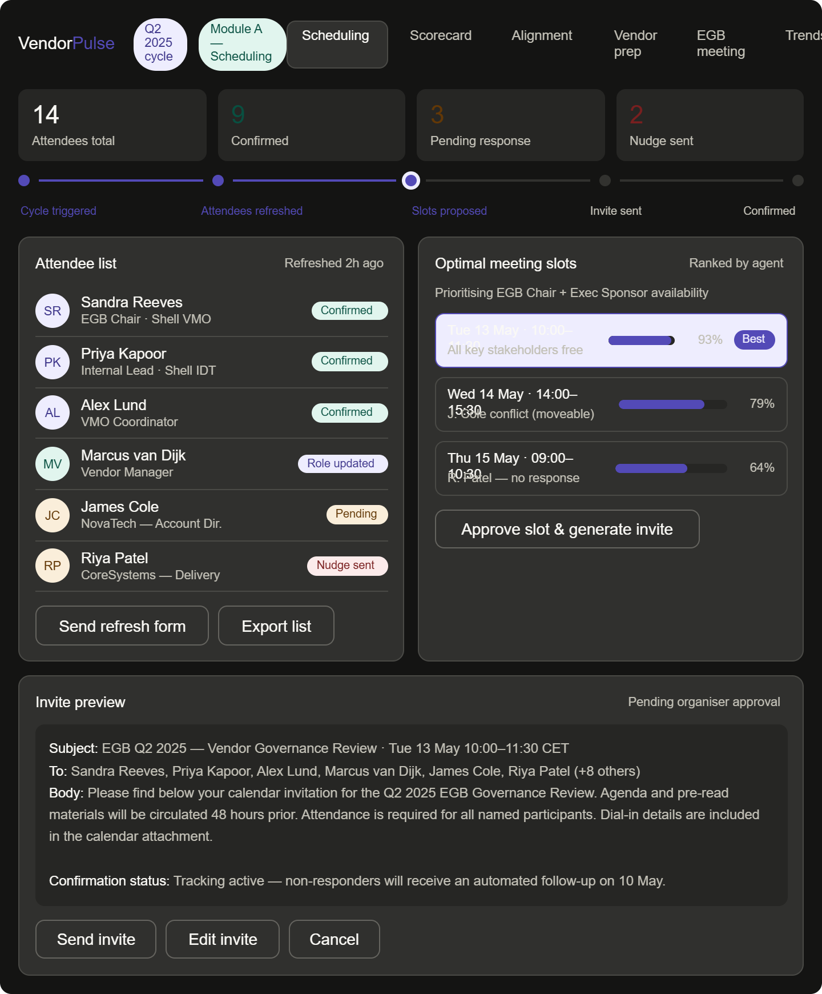
5.A.1 Features
A1 - Attendee Refresh
- The system maintains an attendee list seeded from the last meeting invite.
- On cycle trigger, the agent sends each attendee a short form asking:
  - Are you still part of this team? (Yes / No)
  - If no: Who should replace you? (free text + email)
  - Should anyone else be added to this meeting? (optional)
- Responses are auto-consolidated into an updated attendee list.
- Agent flags unconfirmed attendees after a configurable deadline (default: 48 hrs).
A2 - Availability Check
- Agent sends a scheduling form to all confirmed attendees with 4–6 proposed time slots (pre-generated based on configurable working hours and time zones).
- Slots are ranked by an algorithm that:
  - Prioritises the organiser and executive sponsor availability (hard constraint)
  - Maximises group availability (soft constraint - majority vote)
  - Flags slots where known conflicts exist for non-critical attendees
- Form responses are collected and ranked automatically.
- The agent presents the top 2–3 options to the organiser with a breakdown of who can/cannot attend each.
A3 - Invite Generation & Confirmation Tracking
- On organiser approval of a slot, the agent generates a standard meeting invite (subject, body, attendee list, dial-in details).
- Invite is shown in the UI for organiser to send (one-click dispatch in demo via mock email service).
- The system tracks acceptance/decline status per attendee.
- Automated follow-up nudge sent to non-responders after 24 hrs.
5.A.2 User Stories
- As Alex, I want to send a single attendee refresh form so that the list stays current without manual chasing.
- As Alex, I want the agent to propose the best meeting slot based on key stakeholder availability so that I don't have to manually compare calendars.
- As Alex, I want a live tracking view of who has accepted the invite so that I can follow up on exceptions only.
5.A.3 Acceptance Criteria
- [ ] Attendee refresh form is generated and displayed within the UI
- [ ] Availability ranking correctly prioritises organiser + exec sponsor
- [ ] At least 2 ranked slot options are presented with attendance breakdown
- [ ] Confirmation tracker updates in real time when attendee status changes (simulated in demo)
- [ ] Automated nudge message is generated for non-responders

Module B: Scorecard Input Collection & Validation Agent
Purpose: Replace manual scorecard collection with an automated, validated, agent-driven workflow from request to compiled output.
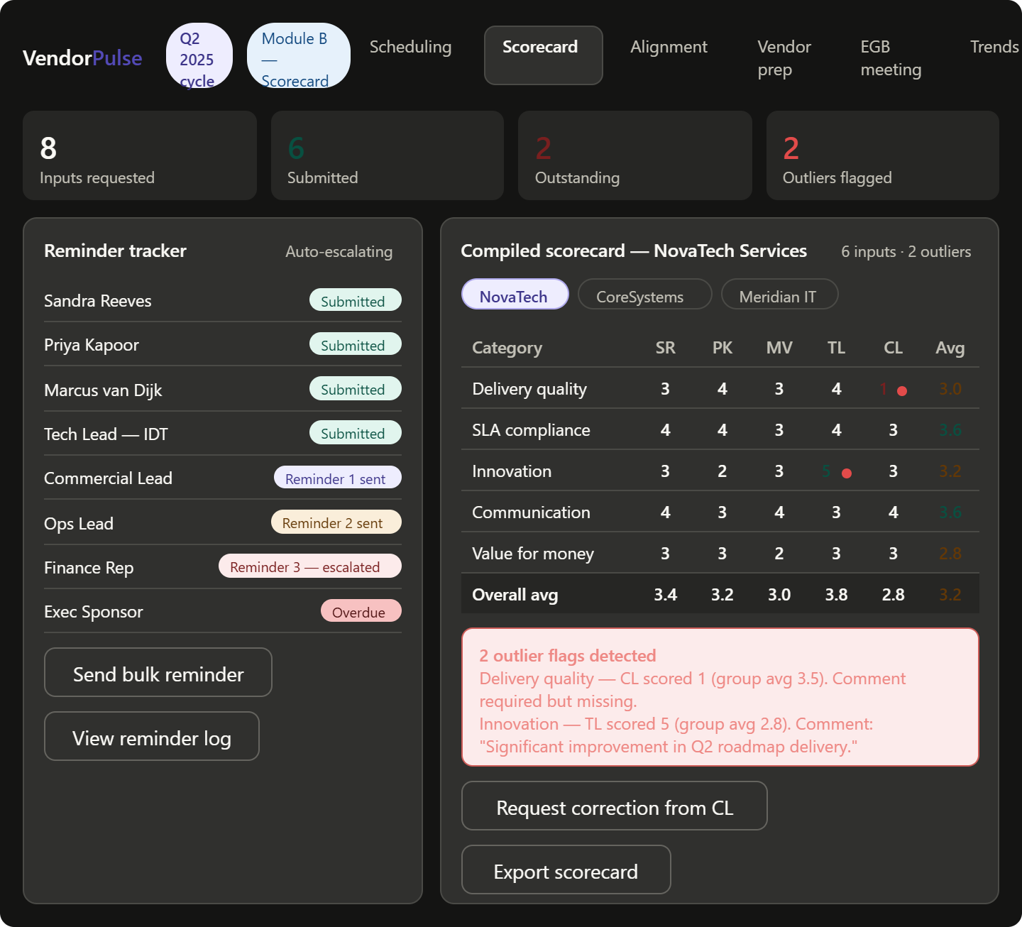
5.B.1 Features
B1 - Scorecard Request Dispatch
- Agent sends a scorecard input request to all relevant stakeholders (configurable per-cycle).
- Request includes: vendor name, scoring categories, description of each category, and submission deadline.
- Supports multiple stakeholder input roles (e.g., VMO Coordinator, Technical Lead, Commercial Lead).
B2 - Automated Reminders
- Configurable reminder schedule: T-5 days, T-2 days, T-day reminders.
- Reminder tone escalates: first reminder is informational, second is a firm deadline notice, third flags to the organiser for manual escalation.
- Reminder history is visible in the UI per stakeholder.
B3 - Input Validation Engine
- On submission, the agent validates each field:
  - Required fields check (no blanks)
  - Numeric range check (scores must be within defined scale, e.g. 1–5)
  - Consistency check: flags if a score deviates more than 1.5 standard deviations from the group average for that category
  - Comment requirement: any score at the extreme ends of the scale (1 or 5) must have a supporting comment
- Invalid submissions trigger an inline correction request to the submitter.
B4 - Compilation & Averaging
- On deadline (or manual trigger), the agent compiles all valid inputs into a consolidated scorecard.
- Auto-calculates average per category and overall weighted average.
- Generates a summary view showing: per-stakeholder scores, averages, outlier flags, and missing inputs.
- Output is displayed as a structured scorecard table in the dashboard.
5.B.2 User Stories
- As Alex, I want the agent to automatically send reminders so that I don't need to chase stakeholders manually.
- As Alex, I want the system to flag outlier scores before the meeting so that we can investigate anomalies in advance.
- As Priya, I want a compiled scorecard with averages calculated so that I can focus on interpreting the data rather than building it.
5.B.3 Acceptance Criteria
- [ ] Scorecard request form is generated with correct categories and deadline
- [ ] At least 3 reminder messages are generated with escalating tone (visible in UI)
- [ ] Outlier scores are visually flagged in the compiled scorecard view
- [ ] Average calculation is correct across a demo dataset of ≥ 4 stakeholder inputs
- [ ] Missing inputs are highlighted with a clear visual indicator

Module C: Internal Alignment Call Support Agent
Purpose: Prepare the internal team for the EGB/QBR by surfacing scorecard changes, flagging alignment gaps, capturing actions, and keeping the face-off model current.
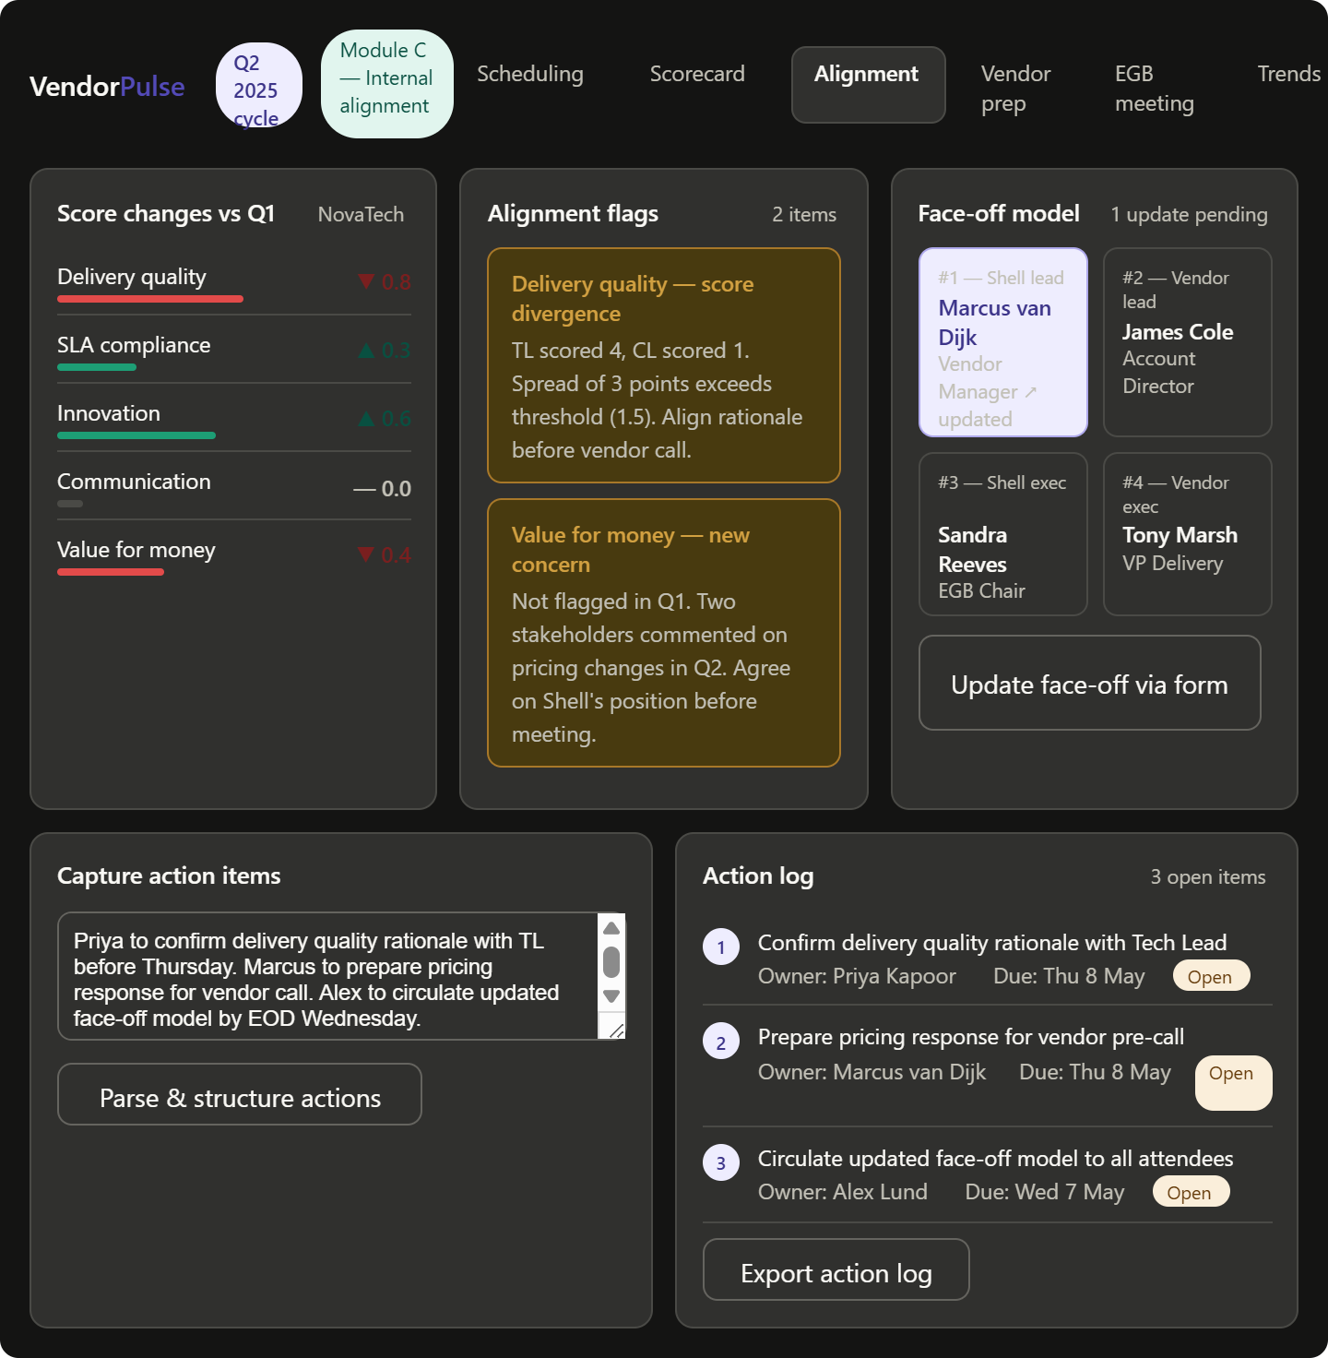
5.C.1 Features
C1 - Change Highlights
- Agent compares the current cycle's compiled scorecard against the previous cycle.
- Automatically generates a "what changed" summary:
  - Scores that increased or decreased by ≥ 1 point
  - Categories where consensus is low (high variance across stakeholders)
  - New issues not present in the prior cycle
C2 - Alignment Flag Engine
- Agent identifies categories where internal stakeholder scores diverge significantly (configurable threshold, default: ≥ 1.5 points spread).
- For each divergence, generates a prompt question for the internal team to resolve before the vendor meeting (e.g., "Technical and Commercial leads differ by 2 points on Delivery Quality - align on rationale before vendor call.").
C3 - Live Action Capture
- During or after the internal call, the coordinator can paste in meeting notes or dictate action items.
- Agent parses the input and structures it into an action log with: action description, owner, due date (extracted or prompted), and status (open by default).
- Action log is persisted and visible in the dashboard.
C4 - Face-Off Model Update
- The face-off model (table of names/roles per numbered position) is displayed in the UI.
- Agent presents each position with the current name/role and asks via a simple form: "Is this still correct? If not, who replaces them?"
- Updates are applied and the revised face-off model is rendered immediately.
5.C.2 User Stories
- As Priya, I want a summary of what changed since last cycle so that I walk into alignment knowing what to focus on.
- As Priya, I want diverging internal scores flagged so that we resolve them before the vendor sees them.
- As Alex, I want to capture actions during the internal call and have them auto-structured so that nothing falls through the cracks.
5.C.3 Acceptance Criteria
- [ ] Change highlights correctly identify ≥ 1 score movement vs prior cycle in demo data
- [ ] At least one alignment flag is generated from demo dataset
- [ ] Action log correctly parses a sample note input into structured action items with owner and due date
- [ ] Face-off model update form renders and applies changes correctly

Module D: Vendor Prep Call Support Agent
Purpose: Equip the Shell team with a vendor-ready brief and tools to manage pushback professionally and consistently.
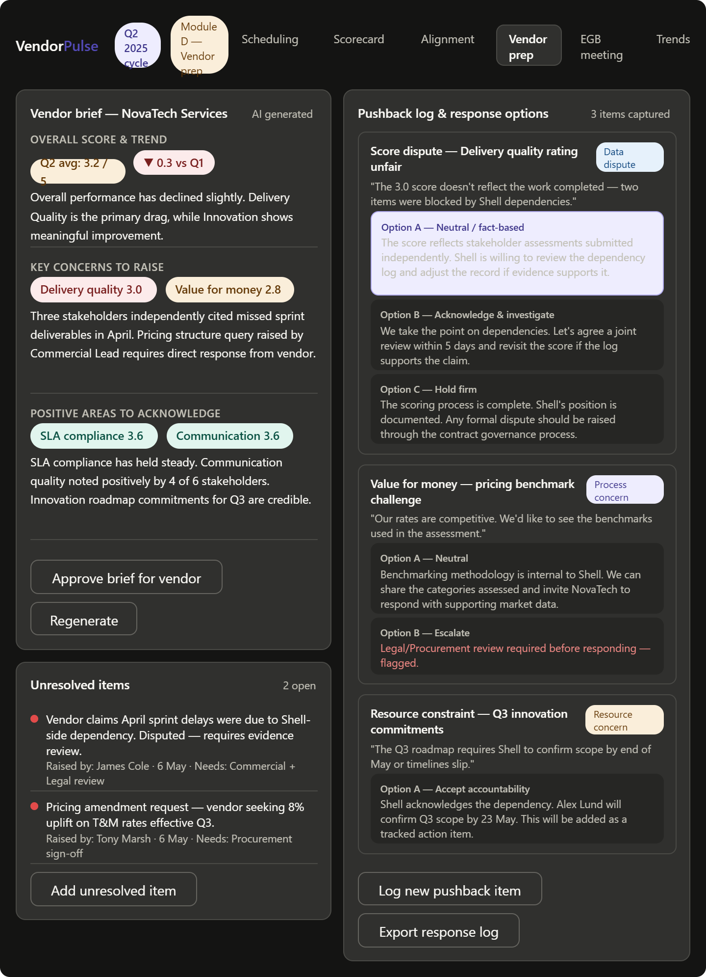
5.D.1 Features
D1 - Vendor Scorecard Brief
- Agent generates a structured brief summarising:
  - Overall score and trend vs prior cycle
  - Category-by-category ratings with rationale (drawn from stakeholder comments)
  - Key concerns to raise with the vendor
  - Positive areas to acknowledge
- Brief is formatted for human review before sharing.
D2 - Pushback Collection & Response Drafting
- A structured form captures vendor questions, objections, or pushback items during or after the prep call.
- For each item, the agent:
  - Categorises the pushback (e.g., data dispute, process concern, resource constraint)
  - Drafts 2–3 response options for Shell internal review (from a neutral, fact-based, and firm escalation stance)
  - Flags items that require legal/commercial review (out of scope for agent action)
- Unresolved items are tracked in an open issues log.
D3 - Unresolved Item Tracker
- All items not resolved during the prep call are logged with: description, raised by, date, and resolution status.
- Agent generates a follow-up list to be actioned before the EGB/QBR.
D4 - Live Action Capture & Face-Off Update
- Same functionality as Module C3 and C4, contextualised for the vendor prep call.
5.D.2 User Stories
- As Marcus, I want a ready-to-use vendor brief so that I don't need to manually extract data from the scorecard.
- As Marcus, I want draft responses to vendor objections so that I have a starting point rather than responding ad hoc.
- As Marcus, I want a tracker of unresolved issues so that nothing is forgotten between the prep call and the EGB.
5.D.3 Acceptance Criteria
- [ ] Vendor brief is generated from demo scorecard data with correct summaries
- [ ] At least one pushback item triggers 2+ draft response options
- [ ] Pushback categories are correctly assigned to a demo set of ≥ 3 objections
- [ ] Unresolved item tracker displays open items with status

Module E: EGB/QBR Meeting Support Agent
Purpose: Provide real-time support during the live governance meeting - capturing content, identifying insights, and generating post-meeting artefacts automatically.
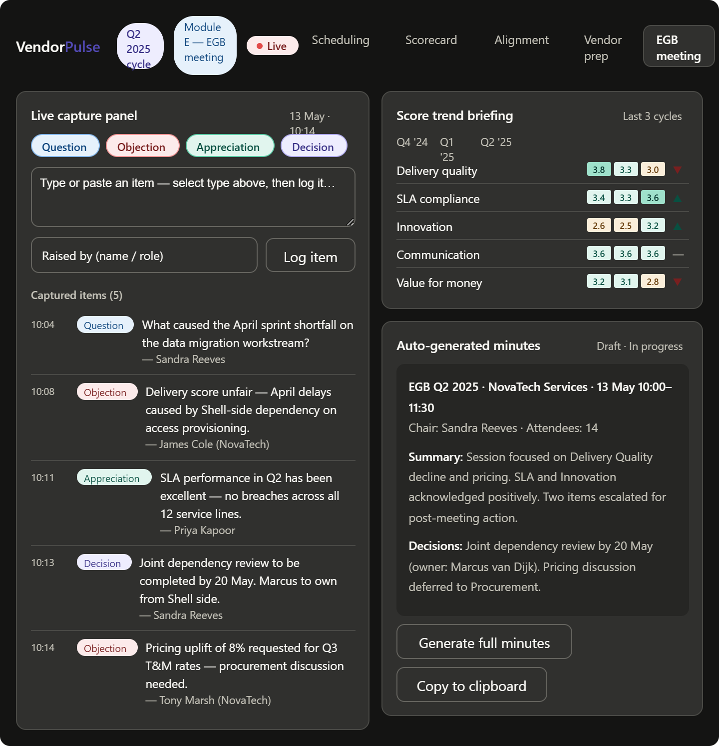
5.E.1 Features
E1 - Score Trend Briefing
- At meeting start, the agent presents a 1-page trend summary:
  - Score movement over the last 3 cycles per vendor
  - Highlight of most improved and most concerning areas
  - Predicted areas of vendor challenge based on prior cycles
E2 - Real-Time Capture Panel
- A live input panel allows the meeting facilitator (or a note-taker) to log:
  - Questions raised (with asker role)
  - Objections received (with categorisation)
  - Appreciations / positive acknowledgements
  - Decisions made
- Each item is timestamped and tagged by type.
E3 - Automated Meeting Minutes
- Post-meeting (or on-demand during the meeting), the agent generates structured minutes from the captured items.
- Minutes format:
  - Meeting metadata (date, attendees, cycle reference)
  - Executive summary (2–3 sentences, LLM-generated)
  - Agenda item summaries
  - Key decisions
  - Full Q&A / objection log
- Minutes are displayed in the UI and available for export (copy to clipboard for demo purposes).
E4 - Action Log
- All action items surfaced during the meeting are automatically extracted from the capture panel entries.
- Each action item includes: description, owner (if mentioned), due date (if mentioned), source (which agenda item), and status.
- Action log is merged with any prior open items from Module C and D.
5.E.2 User Stories
- As Sandra, I want a trend summary before the meeting starts so that I'm briefed without reading through historical scorecards.
- As Alex, I want to capture questions and objections in real time so that nothing is lost during the meeting.
- As Sandra, I want meeting minutes generated automatically so that I don't need to write them up after the call.
5.E.3 Acceptance Criteria
- [ ] Trend summary displays score movement for ≥ 3 cycles from demo data
- [ ] Real-time capture panel accepts and categorises at least 4 item types
- [ ] Meeting minutes are generated from captured items within the demo session
- [ ] Action log correctly extracts ≥ 3 action items from a sample meeting transcript
Module F: Cross-Cycle Memory & Trend Analysis Dashboard
Purpose: Give the Shell VMO team persistent institutional memory across EGB/QBR cycles - eliminating the reliance on individual recall and scattered spreadsheets.
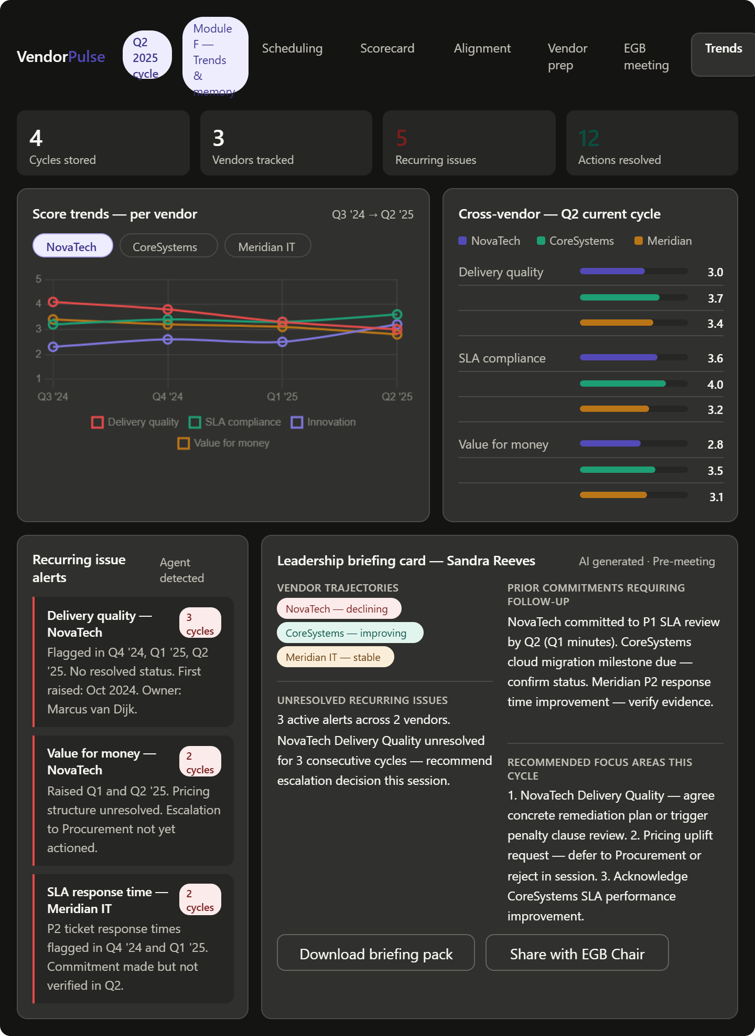
5.F.1 Features
F1 - Historical Score Store
- System stores scorecard data per vendor per cycle.
- Demo data: 4 pre-seeded historical cycles with realistic score variations per vendor.
- Data model supports: vendor, cycle date, category, score, stakeholder, comments.
F2 - Trend Charts
- Per-vendor, per-category score trend chart (line chart over cycles).
- Overall vendor health chart (radar/spider chart showing current vs prior cycle).
- Cross-vendor comparison chart for the current cycle.
F3 - Recurring Issue Detection
- Agent scans historical action logs and flags any issue that has appeared in ≥ 2 prior cycles without a "resolved" status.
- Recurring issues are surfaced as alerts on the dashboard (e.g., "Delivery Quality has been flagged for 3 consecutive cycles for Vendor X").
- Alert includes: issue description, first raised date, number of occurrences, last owner.
F4 - Leadership Preparation Insights
- Agent generates a pre-meeting briefing card for the EGB Chair summarising:
  - Vendor trajectory (improving / stable / declining)
  - Unresolved recurring issues
  - Items agreed in prior meetings that require follow-up
  - Recommended focus areas for this cycle's discussion
5.F.2 User Stories
- As Sandra, I want a vendor trend view so that I can see whether performance is genuinely improving or just fluctuating.
- As Priya, I want recurring issues surfaced automatically so that I'm not relying on memory to spot patterns.
- As Sandra, I want a pre-meeting brief generated for me so that I'm prepared without spending time in spreadsheets.
5.F.3 Acceptance Criteria
- [ ] Trend charts render correctly from 4-cycle demo dataset
- [ ] At least one recurring issue is flagged from pre-seeded demo data
- [ ] Leadership briefing card is generated and contains all four sections
- [ ] Cross-vendor comparison chart displays correct current-cycle data

6. Non-Functional Requirements
Category | Requirement
Performance | All agent responses render within 5 seconds in demo environment
Reliability | Demo flows must be reproducible with no manual resets required between runs
Mock data fidelity | All demo data uses realistic energy-sector vendor names, categories, and scores
LLM output quality | All LLM-generated outputs (minutes, briefs, response drafts) reviewed and locked before demo day
Accessibility | UI must be usable on a standard laptop browser at 1280×800 resolution
Portability | Deployed on a single public URL accessible without VPN

7. Demo Narrative Flow
The prototype must support the following sequential demo script (30 minutes):
Step | Module | What is shown
1 | A | Cycle trigger fires to attendee refresh form generated and sent
2 | A | Availability responses received to agent ranks optimal meeting slots
3 | B | Scorecard request dispatched to reminder escalation shown
4 | B | Inputs received to outlier flagged to compiled scorecard displayed
5 | C | Change highlights vs prior cycle to alignment flag raised
6 | D | Vendor brief generated to vendor objection entered to response options drafted
7 | E | Live meeting: items captured to minutes auto-generated to action log produced
8 | F | Trend dashboard: recurring issue alerted to leadership brief generated
Each step must be triggerable by a button or form action - no manual data entry required during the demo.

8. Technical Architecture (Prototype)
8.1 Component Overview
┌─────────────────────────────────────────────────────┐
│ VendorPulse UI │
│ React + Vite + Tailwind + shadcn/ui │
└──────────────────────┬──────────────────────────────┘
│ REST API
┌──────────────────────▼──────────────────────────────┐
│ Agent Orchestration Layer │
│ FastAPI (Python) + LangChain / direct │
│ tool-call pattern per agent module │
└────┬──────────────┬──────────────┬──────────────────┘
│ │ │
┌────▼────┐ ┌──────▼──────┐ ┌───▼──────────────────┐
│ LLM │ │ Mock APIs │ │ Scorecard Data Store │
│ Claude │ │ Calendar / │ │ SQLite + 4-cycle │
│ API │ │ Email / Form│ │ seed data │
└─────────┘ └─────────────┘ └──────────────────────┘
<Architectural Diagram to be included - https://excalidraw.com/#room=735138ba43a84284deac,cnPDqvft0TX6x7wrY-BlRA>
8.2 Agent Tool Pattern
Each agent module is implemented as a tool-calling agent with:
- A system prompt defining its role and constraints
- A set of tools (functions) it can call (e.g., get_attendee_list, calculate_averages, flag_outliers)
- A structured output schema (JSON) that the UI consumes
- A human-in-the-loop approval step before any "send" action is executed
8.3 Data Seed Requirements
Pre-seeded demo data must include:
- 3 vendors: "NovaTech Services", "CoreSystems Ltd", "Meridian IT"
- 4 historical EGB cycles (Q1–Q4 of the previous year)
- 5 scoring categories: Delivery Quality, SLA Compliance, Innovation, Communication, Value for Money
- 8–10 pre-defined attendees across Shell VMO, IDT, and vendor teams
- 2 recurring unresolved issues per vendor in the historical action log

9. Out-of-Scope Clarifications (Prototype v1.0)
Capability | Status | Notes
PPT slide auto-population | Out of scope | Acknowledged in source doc as not viable for automation
Real calendar integration (Outlook/Google) | Out of scope | Mock API with fixture data used
Real email dispatch | Out of scope | Email previews shown in UI only
Shell-branded template compliance | Out of scope | VendorPulse uses its own clean UI
Contract management (Section B) | Out of scope | Phase 2 roadmap item
Strategic / relationship decisions | Out of scope | AI assists; human decides - always
Legal / contractual interpretation | Out of scope | Flagged items are escalated to human review

10. Success Criteria for Demo Day
The prototype is considered demo-ready when:
- All 6 modules are accessible from the main dashboard
- The 8-step demo narrative can be executed end-to-end without errors
- At least 3 LLM-generated outputs (minutes, brief, trend insights) are of presentation quality
- The recurring issue alert fires correctly from pre-seeded data
- The UI is deployed on a public URL and loads within 3 seconds
- A non-technical observer can follow the demo narrative without explanation of technical steps

11. Risks & Constraints
Risk | Mitigation
LLM hallucination in generated minutes or briefs | All LLM outputs are pre-reviewed and locked to a fixed demo transcript; live generation used for non-critical fields only
Demo data feels unrealistic | Seed data reviewed by architect and a domain-aware team member before Day 4
Integration complexity between modules | All modules share a single JSON data contract; orchestration layer enforces schema
Scope creep from team | Architect holds scope freeze after Day 1; any new feature goes into a backlog, not the sprint

12. Appendix - Glossary
Term | Definition
EGB | Executive Governance Board - Shell's senior vendor governance forum
QBR | Quarterly Business Review - operational vendor performance review cycle
VMO | Vendor Management Office - Shell team responsible for vendor governance
IDT | Information & Digital Technology - Shell's IT function
Face-off model | A structured table mapping Shell and vendor roles/names to governance responsibilities
Cross-cycle memory | Persistent storage of historical scorecard data, actions, and decisions across governance cycles
Agentic AI | An AI system that takes multi-step actions using tools and memory to complete a goal autonomously, with human oversight checkpoints

